**COMET BAY COLLEGE**

**Physics Unit 3 – Task 3**

**Circular Motion Validation Test**

**Name: SOLUTION Total Marks /35**

**Part A** has to be handed in at the **commencement** of this test.

Standard school penalties apply for not meeting the deadline.

|  |  |
| --- | --- |
| Part A | /15 |
| Part B | /35 |
| Total | /50 | % |

1. Reflecting back on the experiment you completed what did the trend of your experiment suggest about the relationship between the centripetal force and the radius. (1 mark)

___________________________________________________________________

1. Assuming that the stopper was perfectly horizontal during the experiment, discuss two errors and in detail, how they would affect the results. (4 marks)

_____________________________________________________________________________________________________________________________________________________________________________________________________________________________________________________________________________________________________________________________________________________________________________________________________________________________________________________________________________________

1. Using your knowledge of centripetal force explain how this type of experiment could be relevant to the real world and improve society. (4 marks)

_____________________________________________________________________________________________________________________________________________________________________________________________________________________________________________________________________________________________________________________________________________________________________________________________________________________________________________________________________________________

A group of students in your class (Max, George and Rachael) are also conducting an experiment where a rubber stopper was whirled around in a horizontal plane, as shown below. However, in their experiment the radius was to remain constant, but the hanging mass changed.

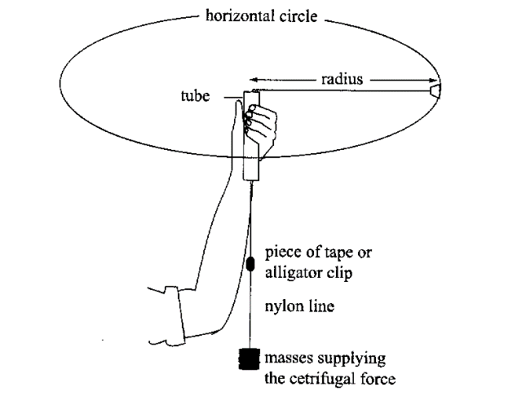

The following results were recorded.

1. Complete the line of data. (working space below table ) (4 marks)

**Table 1: Recorded data of stopper revolving with a variable mass and a radius of 0.6 m.**

|  |  |  |  |  |  |  |  |
| --- | --- | --- | --- | --- | --- | --- | --- |
| Mass (kg) | Calculated Centripetal Force (N) | Time for 20 turns | | | Average time per turn (s) | Velocity  (m s-1) | Velocity2  (m2 s-2) |
| Trial 1 | Trial 2 | Trial 3 |
| 0.2 |  | 10.42 | 11.21 | 9.75 |  |  |  |

1. Assuming the students used a metre ruler with mm graduations and a stopwatch which measures to 1/10th of a second, calculate the percentage uncertainty for the velocity calculation. (4 marks)
2. Halfway through using the 200 gram mass, it was misplaced. So the students had to start over, but this time they had no way of measuring the mass. So the students completed the experiment, but they used a different mass and still with a constant radius of 0.600 m. They plotted the attached graph.

Analyse their graph and data to determine the mass of the rubber stopper used. Show all necessary calculations and logic. (7 marks)

|  |  |
| --- | --- |
| Velocity Squared  (m2 s-2) | Force  (N) |
| 6.5 | 0.5 |
| 20 | 1.5 |
| 33.5 | 2.5 |
| 47 | 3.5 |
| 59 | 4.5 |
| 74 | 5.5 |

1. One of the major errors of this experiment is that the mass is not spinning horizontally. Briefly describe how this can affect the experiment? (3 marks)

______________________________________________________________________________________________________________________________________________________________________________________________________________________________________________________________________________________________________________________________________________________________________________________________________________________________________________________________________________________________________________________________________________________________________________________________________________________________________________________________________________________________

1. What is an appropriate aim for this experiment (2 marks)

______________________________________________________________________________________________________________________________________

1. What is an appropriate hypothesis for this experiment (3 marks)

_______________________________________________________________________________________________________________________________________________________________________________________________________________________________________________________________________________________________________________________________________________

1. Complete the following:
2. Independent Variable: (1 mark)

________________________________________________________________

1. Dependent Variable: (1 mark) ________________________________________________________________
2. Controlled Variables: (1 mark) ________________________________________________________________________________________________________________________________